

User Manual

ATTENDANCE SYSTEM

2017

Table Of Contents

1 Introduction 3

1.1 IMPORTANT! A Quick Note about the CheckPoint Lexicon 3

1.2 About The User Manual 3

2 Getting Started 4

2.1 Logging In 5

3 User Operations 6

3.1 My Appointments 7

3.2 Find Appontments and Courses 8

3.3 Alter Profile 8

3.4 Log Out 9

3.5 View Courses 10

3.6 Becoming an Attendee 11

3.7 Viewing your Attendance History 12

4 Contact Us 14

# Introduction

Welcome to CheckPoint! The online application that provides an easy to use interface for discovering and becoming an attendee to all kinds of events. Our web service lets you log in wherever you are and stay updated with the all information you need to make sure you arrive at the right place, at the right time and never miss another important meeting again. CheckPoint removes the need for slow, error prone manual attendance checks. Every registered CheckPoint user receives a unique personal identification tag so that each and every time you reach your destination our system will be notified and your attendance will be safely logged. Let CheckPoint help you to attend anything, anytime, anywhere.

## IMPORTANT! A Quick Note about the CheckPoint Lexicon

CheckPoint is a flexible application that can be used for all types of events, meetings and rendezvous. This might include educational courses and lectures, work seminars, leisure activities or any other planned event where people wish to get together. With that in mind, it is important to recognize that within the CheckPoint lexicon an ‘**appointment**’ is the general term used to refer to any independent event that occurs only once. Meanwhile, a ‘**course**’ is the term used to describe a group of events/appointments.

## About The User Manual

This user manual covers all features included in the CheckPoint web application.

# Getting Started

Simply navigate to our homepage [www.CheckPoint.com](http://www.CheckPoint.com) and register an account as a new user by clicking on the ‘Get Started With CheckPoint’ button as indicated below in Figure 2‑1. The requested address does not need to be your home address – you may choose the address where you would like us to deliver your identification tag.

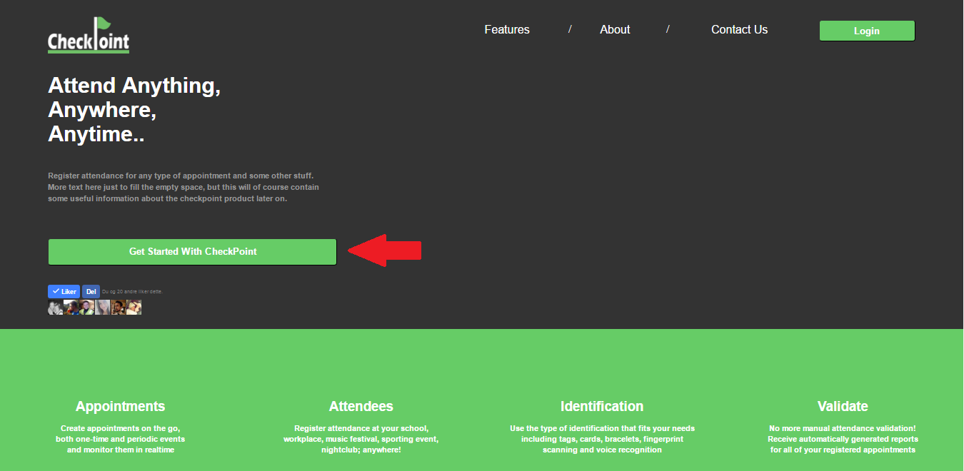

Figure 2‑1Register a new user account by clicking the ‘Get Started With CheckPoint’ button

Once your details have been confirmed and verified you can expect to receive your personal identification tag within 14 days. An example of a CheckPoint identification tag can be seen below in Figure 2‑2. In the meantime, you may log in and start discovering available events that you can apply to attend.



Figure 2‑2 Example of the Identification Tag

## Logging In

Once you click the ‘Login’ button on the homepage, you will be greeted by the log in screen shown in Figure 2‑3. In order to log in to your account, you are required to have a valid user account. If you have not been created a user account, please follow the instructions in the previous chapter ‘Getting Started’. If you have forgotten your login information, please contact the administrator.

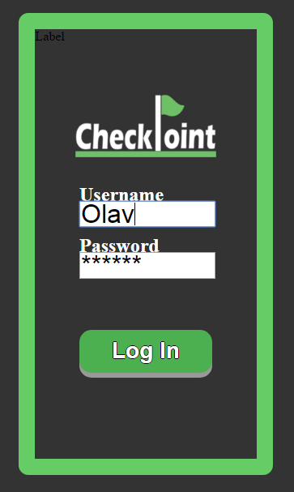

Figure 2‑3: To log in, type in your registered username and password, and click the Login button

# User Operations

Please make sure to read chapter 1.1 ‘A Quick Note about the CheckPoint Lexicon’ before you read this section.

Once you have logged in as a user, you will be greeted by the user homepage as shown in Figure 3‑1. This page will display all of the appointments that you are due to attend. Of course, if you have only just registered your account, you can expect this list to be empty.

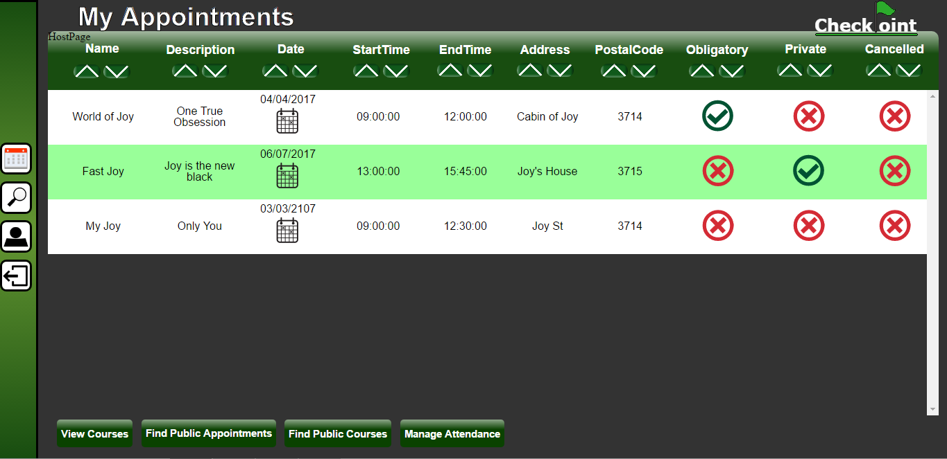

Figure 3‑1 the user homepage showing three appointments

The ‘My Appointments’ table provides a clear way to see at a glance the most important information about each individual appointment. Clicking the calendar icon will open a calendar, as shown below in Figure 3‑2, and display the date in context making it easier to see which day of the week the appointment takes place on.

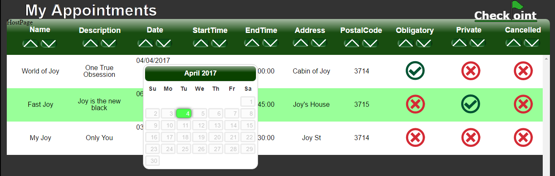

Figure 3‑2 Clicking the calendar icon will show the date in context

As your list of appointments begins to grow it is useful to be able to sort them by name, date, time etc.…. This can be achieved by simply clicking on the appropriate button found at the top of every column as shown in Figure 3‑3.

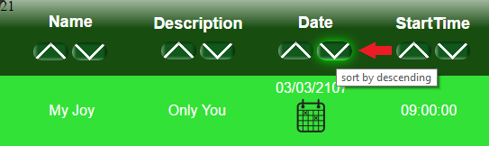

Figure 3‑3 Sorting the list of appointments by date descending order

On the far left side of the screen, you will find the navigation bar. This panel contains four buttons that give quick access to several important functions and is available on every page. At the bottom of each page, you will find a selection of buttons that offer additional functionality specific to each page. We will examine these functions in the sections that follow.

## My Appointments

The ‘My appointments’ button, as shown in Figure 3‑4, is found in the navigation bar and will return you to the first page that you reach upon logging in. This page provides an overview of all the appointments you are due to attend.



Figure 3‑4 'My Appointments' button icon

## Find Appointments and Courses

The ‘Find appointments and courses’ button, as shown in Figure 3‑5, is found in the navigation bar. On clicking this button, you will be directed to a page that lists all the appointments contained in the CheckPoint system that have been designated as public and available for users to attend. Each appointment is displayed such that it is easy to see the most relevant information at a glance.



Figure 3‑5 ‘Find appointments and courses’ button icon

From the same page, it is possible to navigate to a page that lists all of the courses that have been designated to be publicly available in a similar fashion. The button to find courses, as shown in Figure 3‑6, is clearly labelled and found at the bottom of the page.



Figure 3‑6 'Find Public Courses' button

## Alter Profile

You can change your user account information by selecting the “Alter profile” button found in the navigation bar, as illustrated in Figure 3‑7.



Figure 3‑7 'Alter profile' button icon

Here you can update your name and contact information. If you would like to change the username associated with your user account, please contact the administrator.  
When you are satisfied with your changes, click the “Commit Changes” button shown in Figure 3‑8. After you have made the desired changes you will be taken back to the ‘My Appointments’ page.

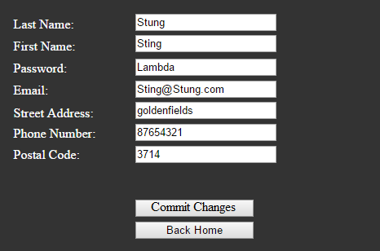

Figure 3‑8 Alter Profile

## Log Out

You may end your session at any point by clicking the ‘Log out’ button found in the navigation bar and illustrated in Figure 3‑2. This will direct you back to the CheckPoint home page.



Figure 3‑9 'Log out' button icon

## View Courses

The ‘View Courses’ button will take you to the page shown in Figure 3‑10 that provides an overview of all the courses which you are due to attend – in much the same way as the ‘My appointments’ page.

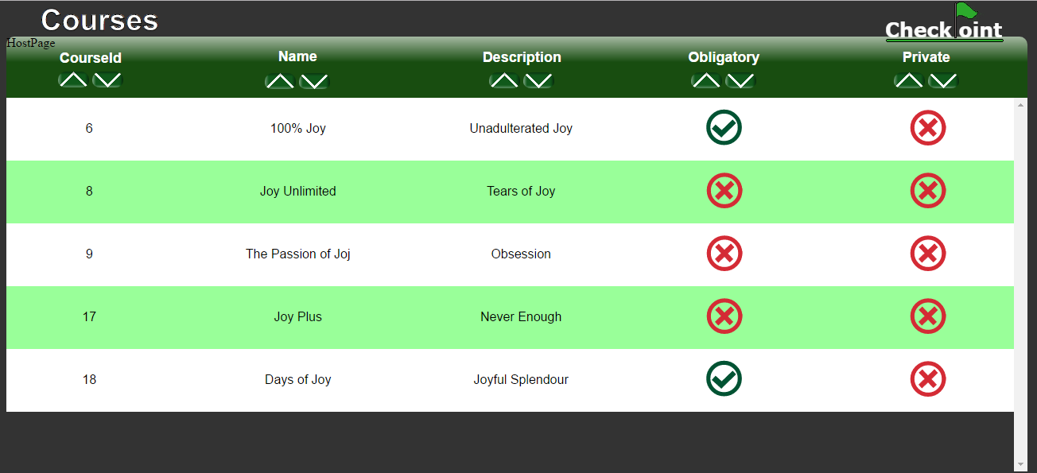

Figure 3‑10 Courses Table

To view more detail about a course simply select the course by clicking the appropriate row with the mouse. A row will change colour to indicate that it has been selected. Next, click the ‘Display selected course’ button. This will present you with information about every appointment belonging to the course as shown in Figure 3‑11.

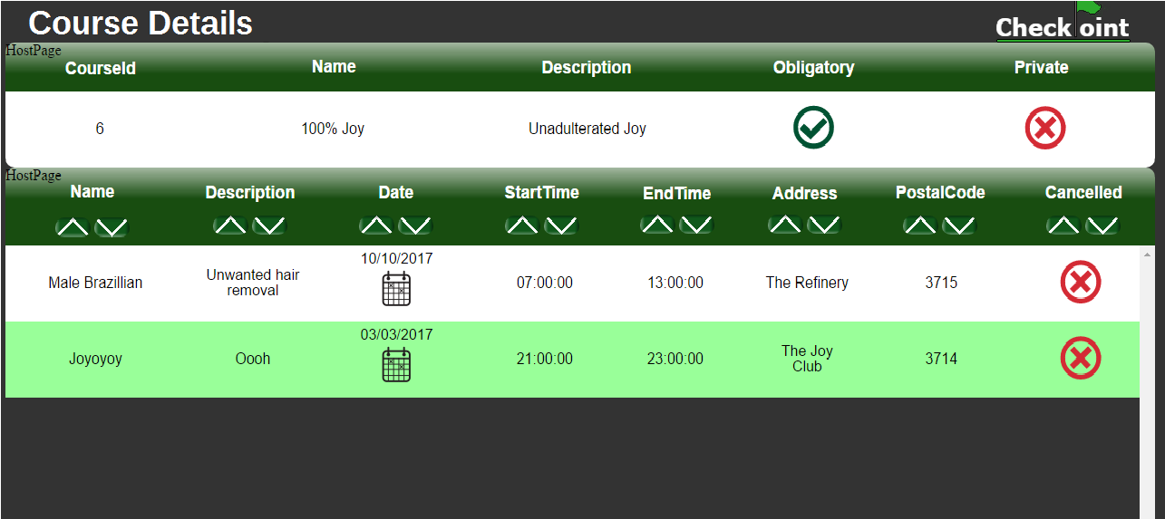

Figure 3‑11 Course Details Page

## Becoming an Attendee

After you have found a course or appointment that you would like to attend, you may apply to attend it. Start by first clicking the appropriate row. A selected row will change colour to indicate that it has been selected. Next, click the relevant button found at the bottom of the page. For applying to an appointment from the ‘find appointments’ page click the ‘Apply to attend the selected Appointment’ button. Likewise, for applying to attend a course from the ‘find courses’ page click the ‘Apply to Attend the Selected Course’ button.

The steps to become an attendee for an appointment are described below.

The process for a course is identical.

Step 1. Find an appointment in the ‘Find Public Appointments’ page as shown in Figure 3‑12.

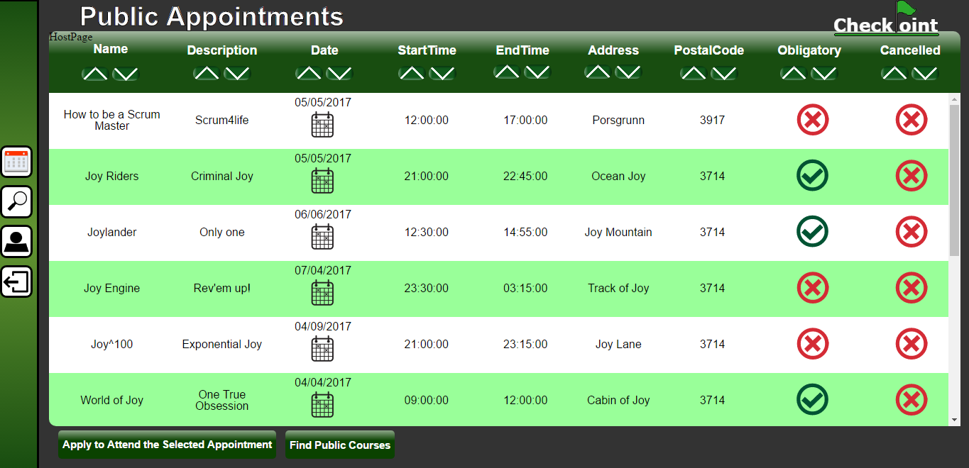

Figure 3‑12 Find Public Appointments Page

Step 2. Select the appointment by clicking anywhere on the row as shown in Figure 3‑13.

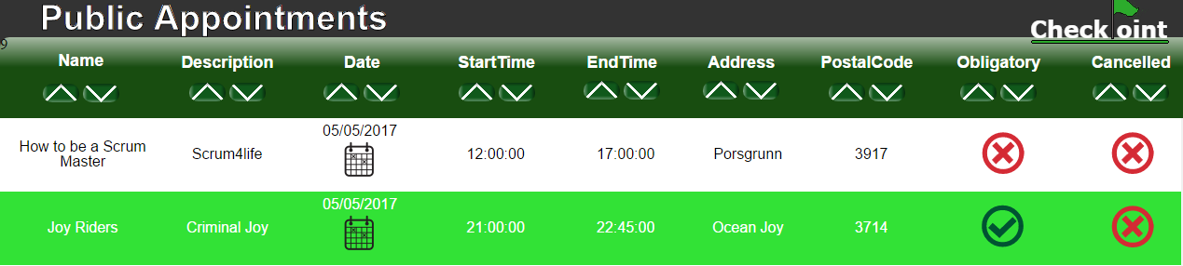

Figure 3‑13 A selected row will turn light green

Step 3. Click the ‘Apply to Attend the Selected Appointment’ button shown in Figure 3‑14



Figure 3‑14 'Apply to Attend the Selected Appointment' button

Congratulations – you have successfully applied to become an attendee to the chosen appointment!

The host or organization responsible for the appointment or course will now be notified and will be able to process your request. Once approved, you will be notified and the appointment or course will be added to your account such that it will be visible in your ‘My Appointments’ page or ‘My Courses’ page.

If there are any changes made to the appointments or courses you will be attending these changes will be instantly updated on your ‘My Appointments’ or ‘My Courses’ helping to keep you informed at all times, wherever you are.

Your personal identification tag will automatically be registered with the event so that your attendance can be verified and recorded on location by a CheckPoint terminal. All you need to do is remember to bring your identification tag and “beep in” by touching your tag to the terminal.

## Viewing Your Attendance History

Once you have attended an appointment your account will be updated so that you can view your attendance history. Simply click the ‘My Attendance History’ button as shown in Figure 3‑15.

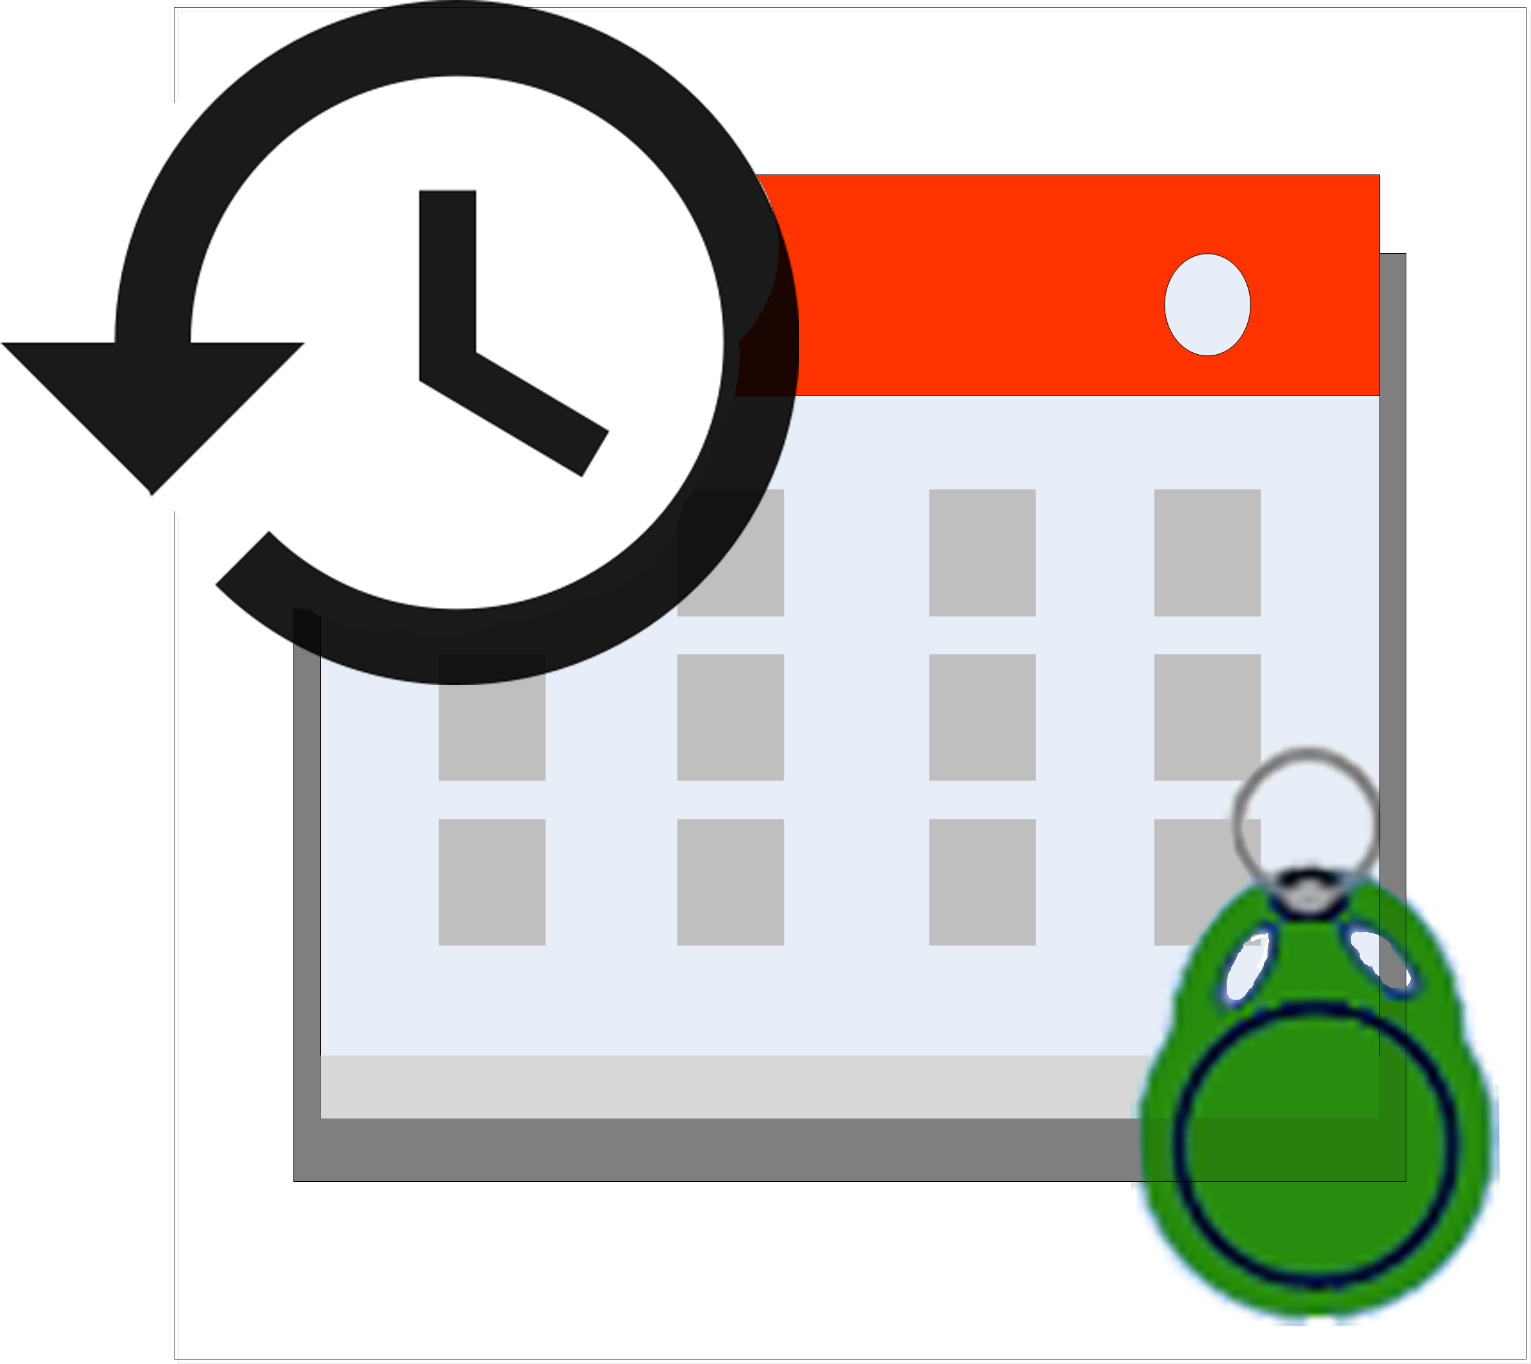

Figure 3‑15 My Attendance History Button Icon

You will be presented with a list of all the appointments you have attended. Next, click on any appointment to see the relevant information about your attendance as shown in Figure 3‑16.

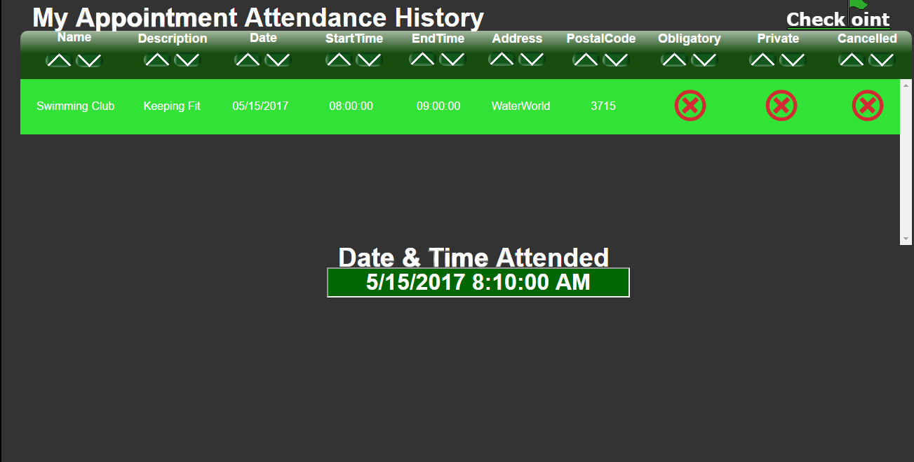

Figure 3‑16 My Appointment Attendance History Page

Thank you for choosing CheckPoint.

# Contact Us

Feel free to contact us should you need any information or if you are experiencing any problems with our product.

* *Support & General:*

+004746837573 (24/7)

* *Email:*

Support@CheckPoint.com